‘La Table de l’Abbé’
The Abbot’s Table

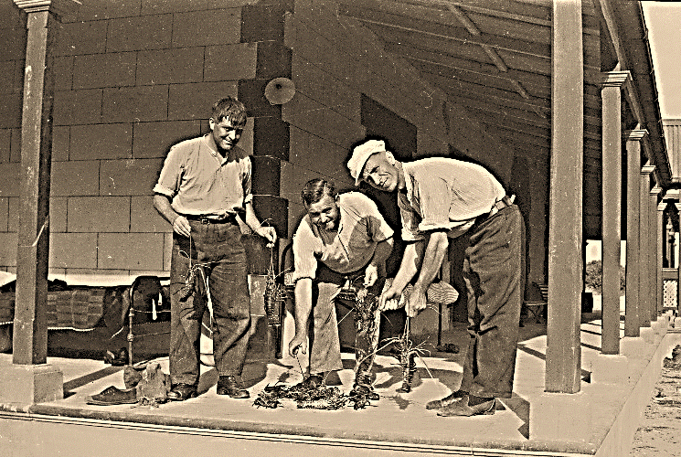
Cray fishing on community summer holiday - Dongara c.1950
Summer
Saturday 18th February 2023
Welcome to the Summer Abbot’s Table!
Last year, my friends John and Nicole (aka ‘the sous-chef’ and ‘the sommelier’) gifted me with signed copies of French chef Guillaume Brahimi’s beautiful books Food for Family and Food for Friends. Both exquisitely produced books are filled with wonderful ideas and very helpful cooking tips, fine photography and inspirational stories of sharing the joys of the table with family and friends. Having read these delightful publications, I was pleased, while in Sydney en-route to Wollongong to give a retreat, to see the first episode of the SBS broadcast of Guillaume’s Paris, an exploration of French gastronomy through each of the arrondissements of this enchanting city. But monastic life back in down-town New Norcia, equally enchanting but for different reasons, prevented me from seeing the rest of the series. However, all was not lost – my disappointment was transformed into gastronomic joy as the same friends treated me to dinner at Bistro Guillaume in Perth for my birthday. It was a night of Lillet cocktails, a surprise bottle of French champagne courtesy of Carmel Murray (aka ‘the maître d’), a bottle of fine Margaret River wine, double baked cheese soufflé for entrée, linguini with blue swimmer crab for main, and more soufflé for dessert…this time Guillaume’s signature passionfruit. I think we were as dizzy with delight… again, for different reasons…as the mighty throng attending the ‘Guns ’n’ Roses’ concert that same evening!
John Cassian, from whom St Benedict sourced inspiration when writing his 6th century rule for monks, suggested that one of the ways we identify or are drawn to our vocation in life is to be inspired by others. Reminiscent of the days when I would spend most of my meagre apprentice chef’s wages (the lofty sum of $89 a week…after tax) on books written by the great French chefs of the 1980s, and after significant pay rises as I made my way through the ranks of Melbourne kitchen brigades, dining in some of their restaurants, I have certainly been inspired by the fine craftsmanship of chef Guillaume, and hope I do him justice in my attempt to make his tomato tart for tonight’s entrée.
Bon appétit!
Le Menu
New Norcia Bread
A selection of hand-crafted bread baked in the monastery
wood-fired oven, New Norcia award-winning
extra virgin olive oil, balsamic vinegar, and French butter.

Entrée
Tarte aux tomates d’été
Guillaume’s warm tart of summer cherry tomatoes, Roma tomato confit, tomato caramel, ricotta, and basil oil.
Vin: New Norcia Abbey Chardonnay-Verdelho 2022

Plat Principal
Du marché aux poissons
Herb crumbed Tasmanian oyster with watercress and lime syrup.
Grilled WA scallop with buttered leek, black garlic and chili oil.
Pan-fried fillet of WA snapper with Pernod fish sauce.
WA tiger prawn in crispy beer batter with Japanese dipping sauce.
Seared marinated WA scampi with dill aioli.
Crispy potatoes and salad of summer leaves in citrus dressing.
Vin: Guillaume Gonnet, Le Hardi Côtes-du-Rhône Villages 2019

Musical Interlude
Fromage
Carefully selected fine cheeses served with summer grapes, fresh honeycomb, quince paste, and New Norcia poppy seed lavosh.

Dessert
Pêche pochée
Summer peach poached in crème de pêche syrup, served with passionfruit glaze, raspberry coulis, and house-churned caramel ice-cream.
Vin: A shot glass of De Bortoli Deen Botrytis Semillon Vat 5

Café Gourmand
Coffee, New Norcia Abbey Port or Liqueur Muscat,
and treats from the monastery wood-fired oven.
Le Vin

New Norcia Abbey Chardonnay-Verdelho 2022
This blended wine is crafted from ripe, hand-picked fruit and barrel-fermented to create a rich, flavoursome wine. It has peachy, tropical fruit characters with integrated oaky and yeasty flavours, excellent depth and a dry finish.

Guillaume Gonnet, Le Hardi Côtes-du-Rhône Villages
A faithful and well above average rendition of the famed Cotes du Rhone red. Produced from a blend of 80% grenache and 20% syrah. Often described as a Baby Châteauneuf du Pape, this wine is rich, complex, yet approachable. Generosity of ripe red fruit and plumminess, aligned with a dusting of light, fine, dry herbs. The finish is round, soft and smooth, the flavour plentiful.

De Bortoli Deen Botrytis Semillon Vat 5
Deen De Bortoli was a true visionary of the Australian wine industry and at the forefront of innovation. This signature dessert wine from the Riverina is brimming with a sweet surrender of honey, apricot jam and marmalade. A cut of crispness on the finish sends it into the realm of sophistication.

